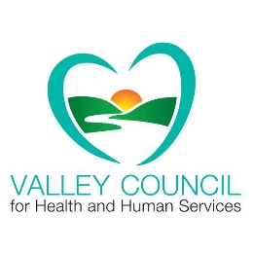**Valley Council for Health and Human Services**

**Cordially invites you to join us at the**

**25th Annual Pillars of the Past Anniversary Meeting**

**Tuesday, December 4, 2018 @ Brownson Country Club, 15 Soundview Ave, Shelton CT**

**Registration & Buffet 7:30-8:00 a.m. Meeting: 8:00-10:00 a.m.**

***Key Note Presentation: A History of the Valley Council Presented by:  
Jack Walsh * Marylin Cormack***

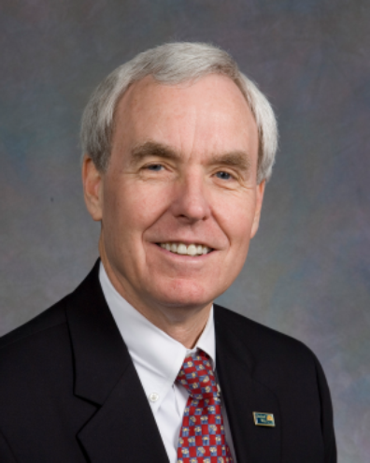 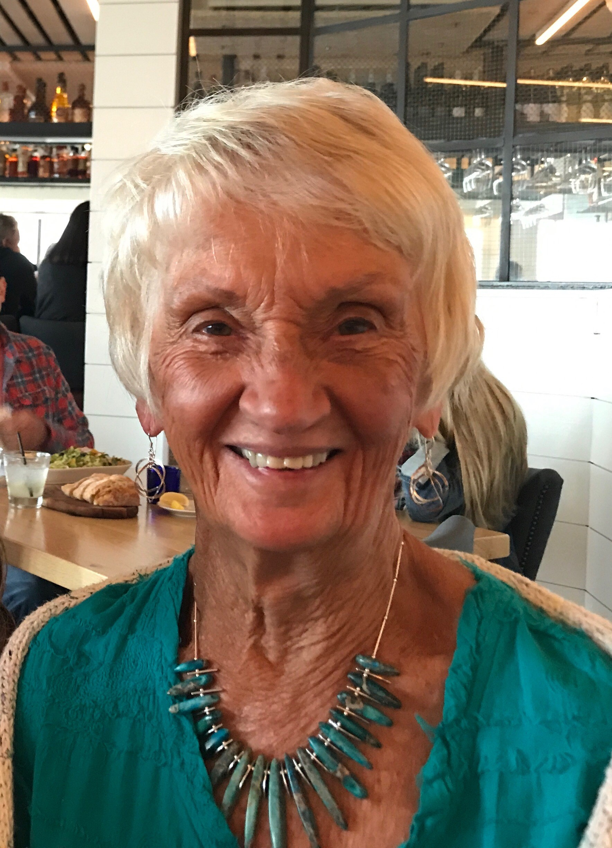

**Presentation of Awards Honoring**

**Food Task Force, John Yeager, and Robert D Scinto**

**Tickets may be purchased in advance on-line, by check or credit card ~ call**

**Valley United Way ~ (203) 926-9478– RSVP by: 11-19-18**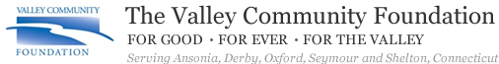

**Marquis Sponsor**

**Valley Council Annual Meeting 2018 Registration Form**

**Name of Attendees(s)**

_________________________________________ _________________________________________

_________________________________________ _________________________________________

__________________________________________ __________________________________________

**Organization Affiliation________________________________________________________**

**__________ Total Registration Fee to Be Submitted: $20.00 Per Person**

**Registration Fee Payment Options:**

**___ Exempt for Award Winner and One Guest**

**___ Online payment – visit** [**www.valleycouncil.org**](http://www.valleycouncil.org) **for a link to the Valley United Way.**

**___ In Advance by check to Valley United Way**

**___ In Advance by credit card call Valley Council – (203) 926-9478 (Linda Milardo - Tues & Thurs)**

**Please submit registration form and payment by November 19th to:**

**Valley Council Health & Human Services (check made out to Valley United Way)**

**Att: L. Milardo**

**54 Grove St, Suite 1**

**Shelton, Ct. 06484**

**If you have any questions, please e-mail Linda Milardo, coordinator for the Valley Council.** [Linda.milardo@valleyunitedway.org](mailto:Linda.milardo@valleyunitedway.org)